

**EE463 Project-1 Report**

Batuhan Bülbül 2030377

Mert Elmas

Table of Contents

Introduction 3

Results 3

Part 1 3

Part 2 4

Part 2.1 4

Part 2.2 9

Part 2.3 10

Part 2.4 11

# Introduction

In this report, single phase diode rectifiers output voltage waveforms and line current characteristics for different types of load are investigated on Simulink. Also, the effect of line inductance is observed. Its assumed that the rectifiers are connected to Turkish grid (400 V l-l, 50 Hz) for this project.

# Results

In this section of report, results of each part are explained separately.

## Part 1

Simulink simulates a dynamic system by computing its states at successive time steps over a specified time. Simulink solvers divided into two basic categories: fixed-step and variable-step. We selected fixed-step solvers for different step sizes. Where the size of the solver time interval is known as the step size. Generally decreasing the step size increases the accuracy of the results while increasing the time required to simulate the system. For example, in the following output voltage waveforms of same topology, the effect of step size can be seen easily between 1.5msec case and the 1usec and 10usec. The difference between step size of 1usec and 10usec is relatively negligible. More accurate and smooth curves are obtained while decreasing step size.

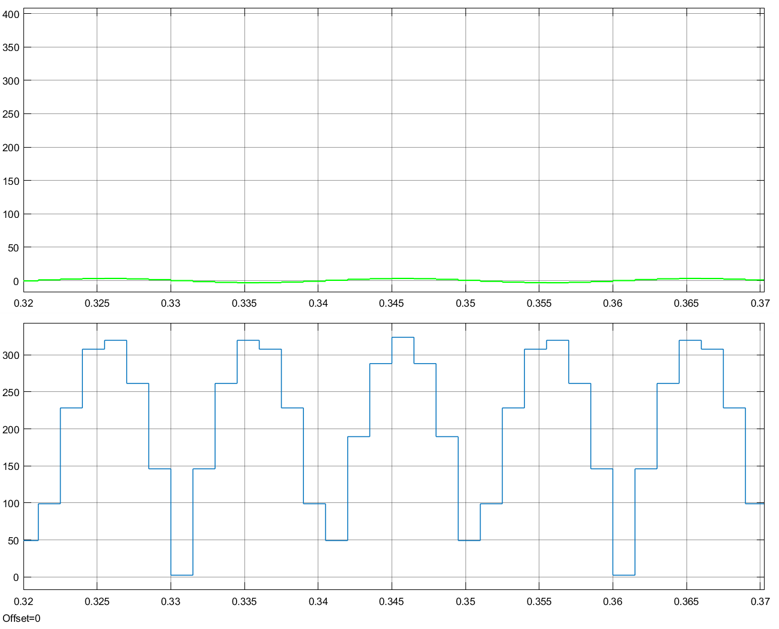

Figure 1: Output voltage waveform simulated with 1.5msec step-size

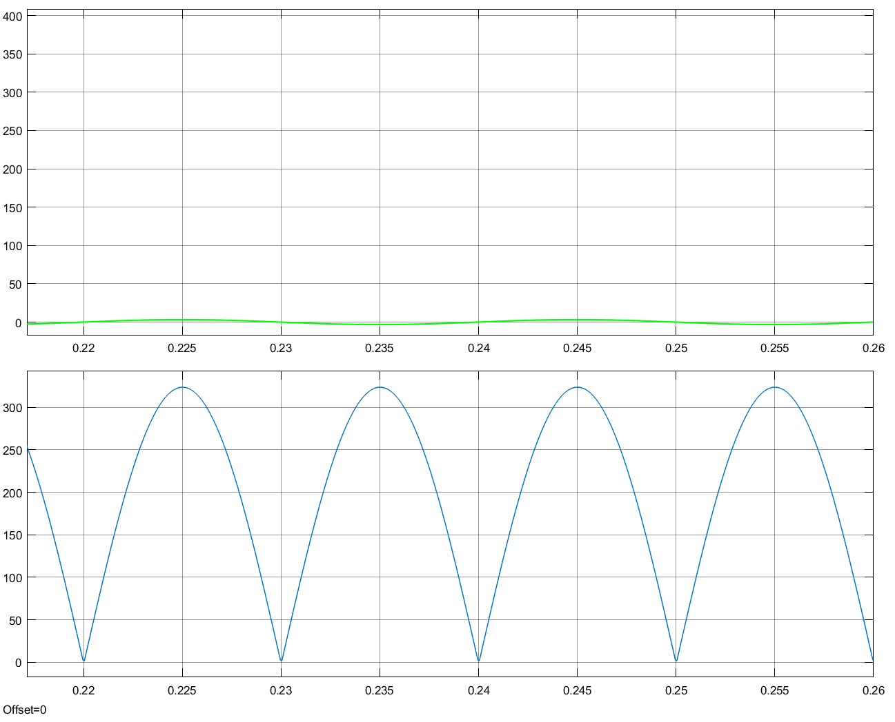

Figure 2: Output voltage waveform simulated with 10usec step-size

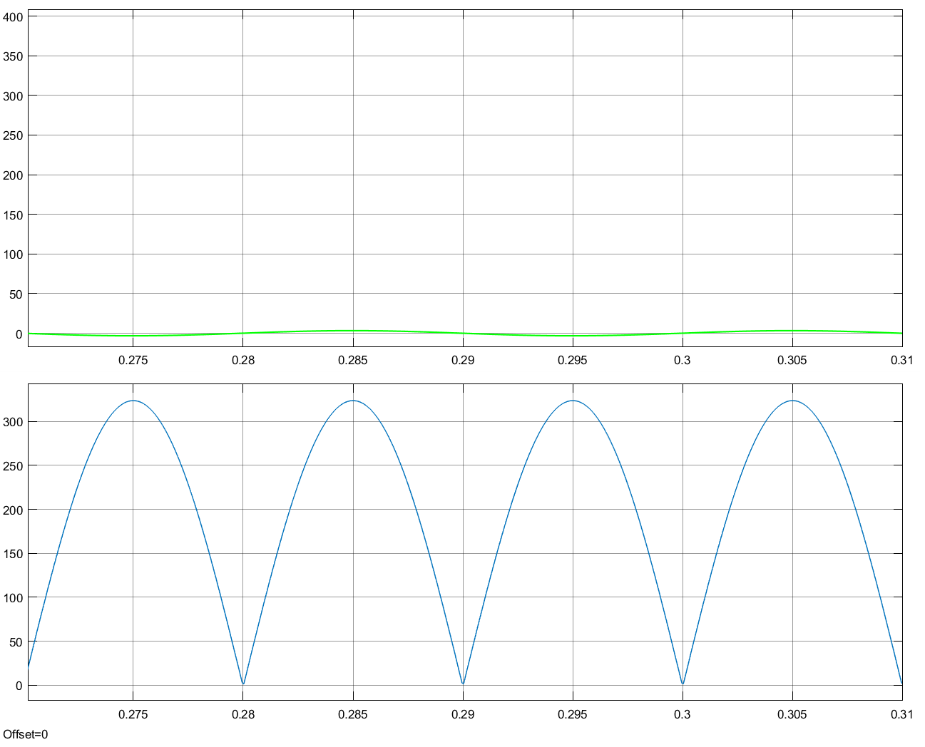

Figure 3: Output voltage waveform simulated with 1usec step-size

## Part 2

Simulation results of a single-phase diode rectifier with different loads are given in this part. Following topology is used by modifying it for different question of part 2.

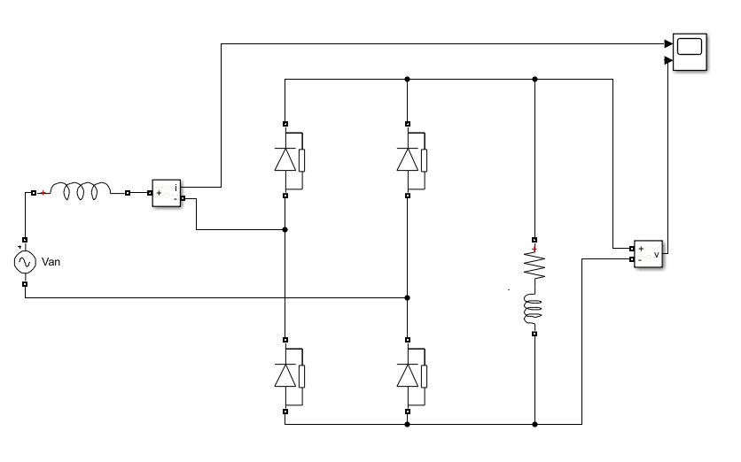

### Part 2.1

Output voltage waveforms at steady state and the average value of the output voltages and THD of the line currents of R=25Ω, R=25Ω with L=10mH, and R=25Ω with L=1H loads are shown in the following figures respectively.

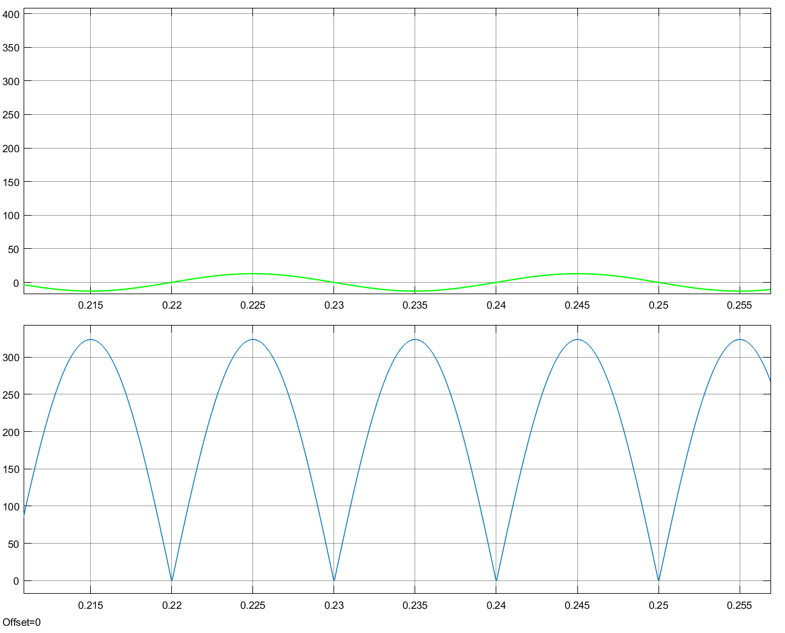

Figure 4: Output voltage waveform with R load R = 25 Ω

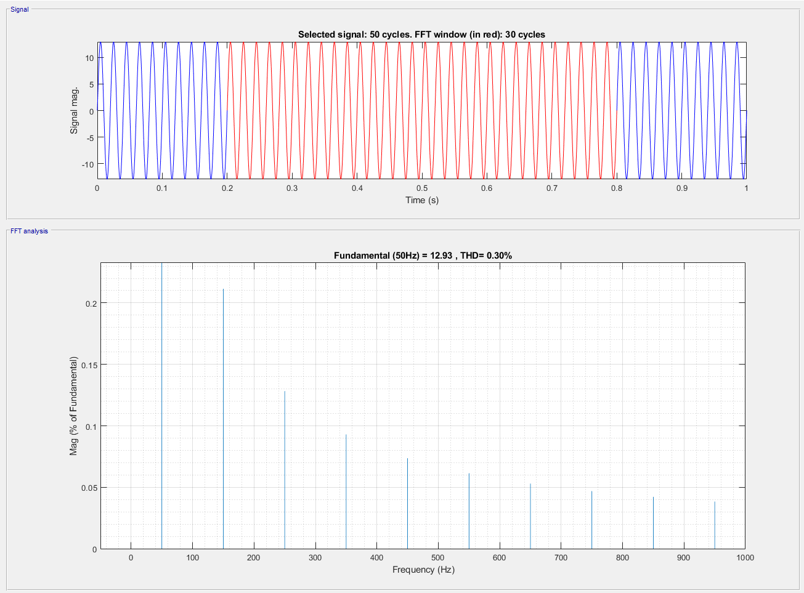

Figure 5: THD=0.3% with R load R=25 Ω

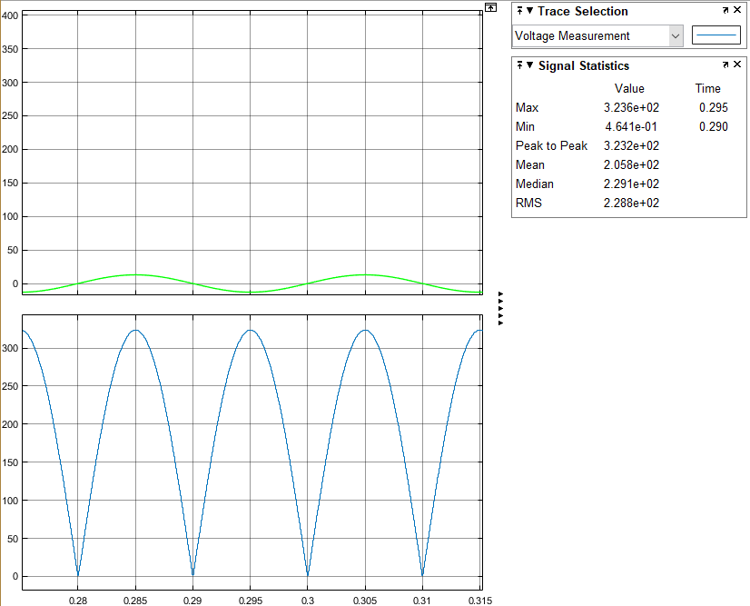

Figure 6: Average output voltage is 205.8V with R load R=25 Ω

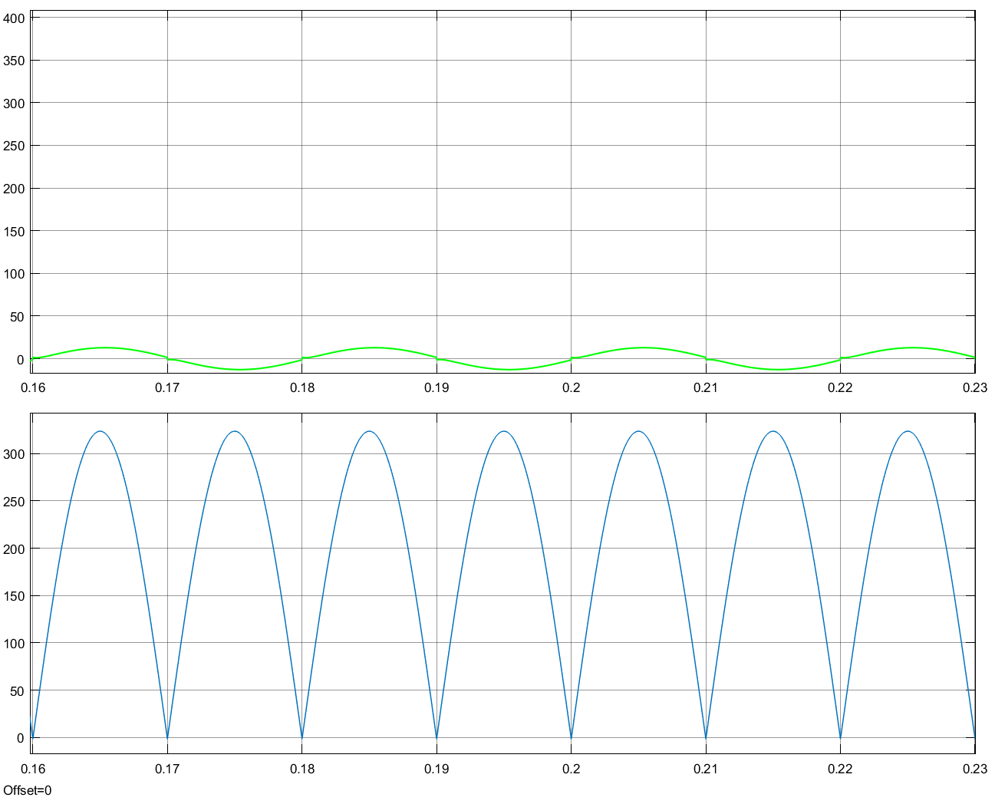

Figure 7: Output voltage waveform with RL load R = 25Ω L=10mH

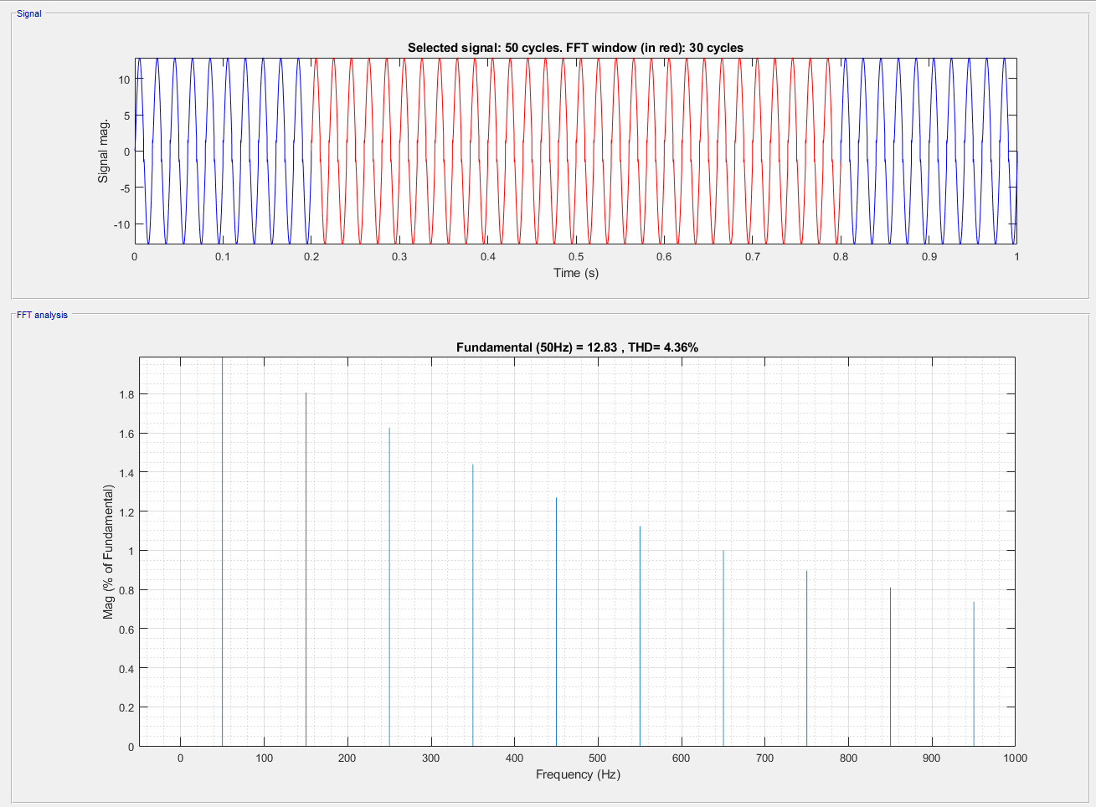

Figure 8: THD= 4.36% with RL Load R=25 Ω L=10mH

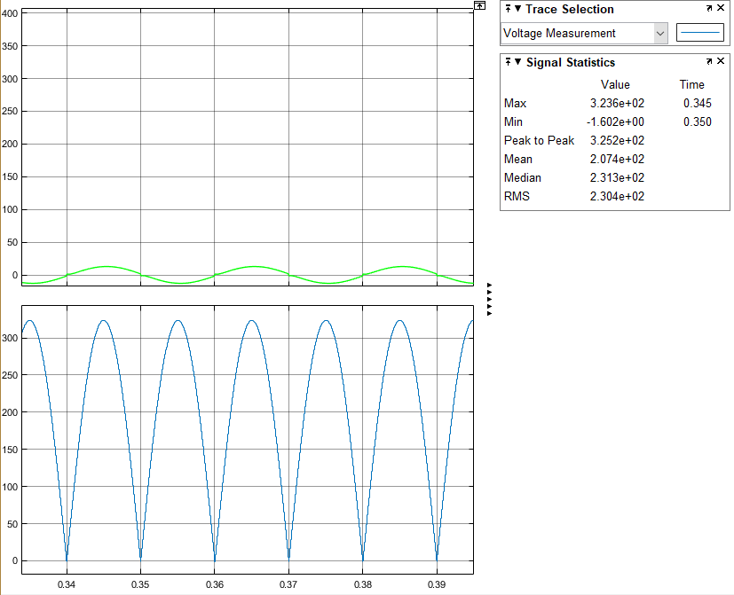

Figure 9: Average output voltage is 207.4V with RL Load R=25 Ω L=10mH

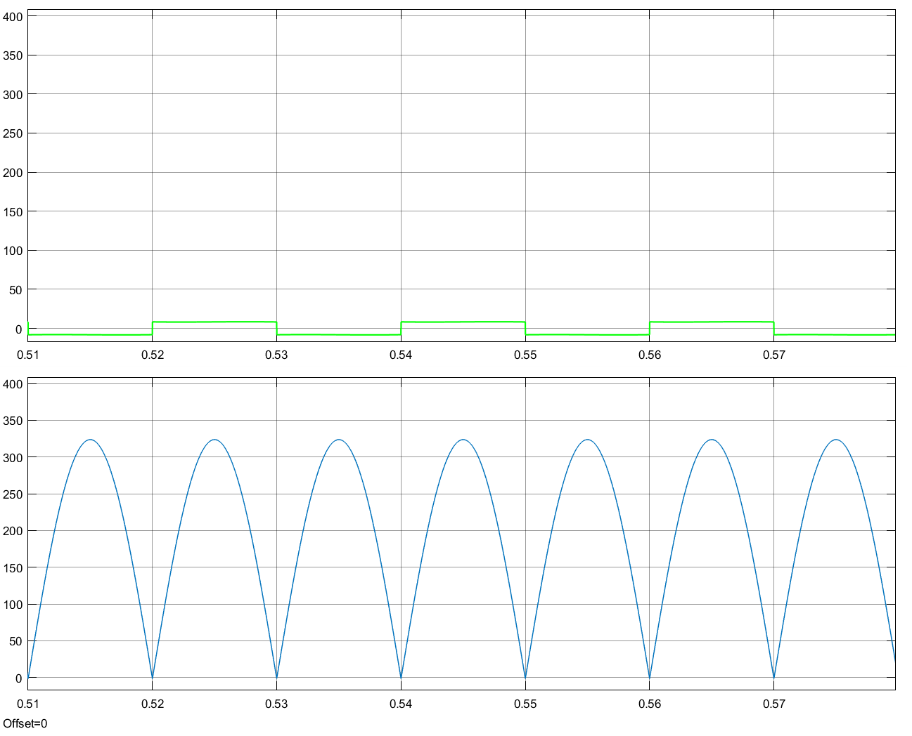

Figure 10: Output voltage waveform with RL Load R= 25Ω L=1H

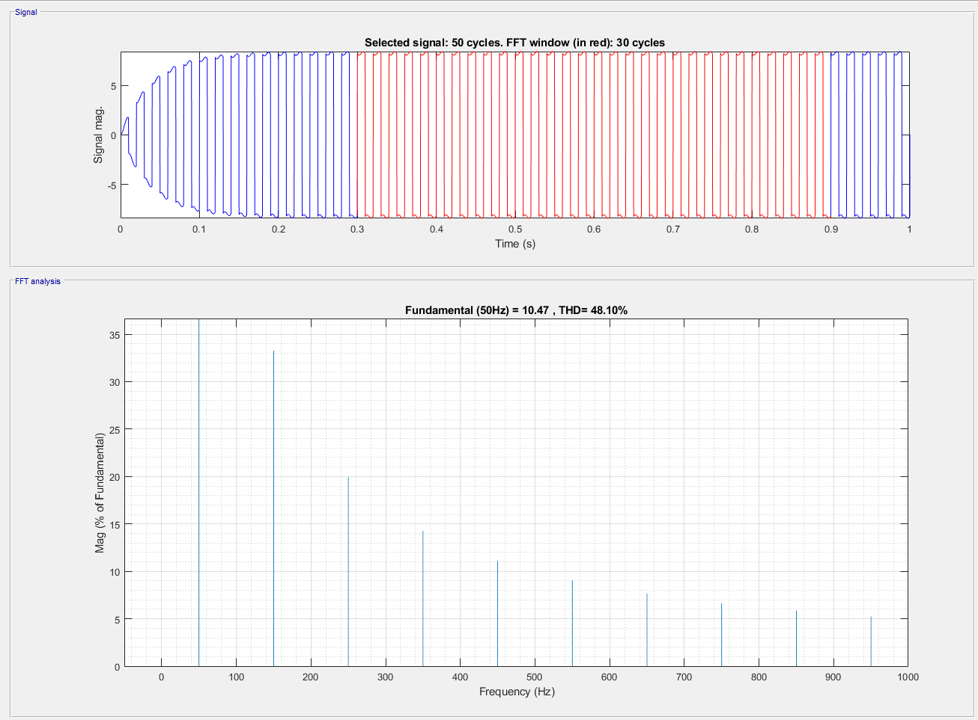

Figure 11: THD= 48.1% with RL Load R=25 Ω L=1H

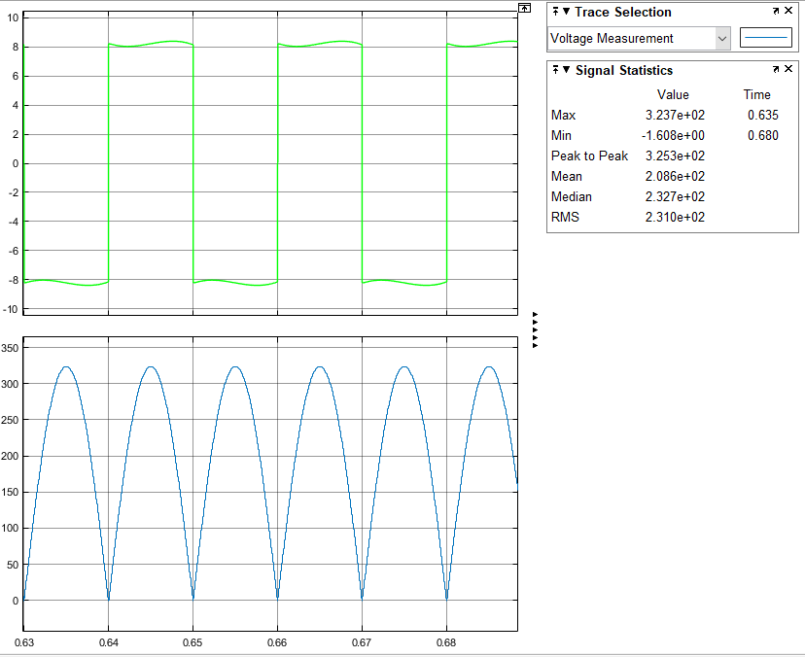

Figure 12: Average output voltage is 208.6V with RL Load R=25 Ω L=1H

Average output voltages slightly differ from each other. This caused by inductance in the load. Moreover, THD of the line currents are increasing while adding or increasing inductance at the load. THD is calculated by using FFT Analysis tool of Simulink. It gives THD automatically. For instance, in the first case where the load is purely resistive, THD of the line current is 0% and with RL load having inductance of 1H, the THD is 48.1%

### Part 2.2

*Forward voltage drop (Vf)*: This diode characteristic is of great importance, especially for power rectification where power losses will be higher for a high forward voltage drop. For low voltage drop Schottky diodes are useful since Schottky diodes will have the lowest forward volts drop.

*Peak Inverse Voltage (PIV):* This diode characteristics is the maximum voltage a diode can withstand in the reverse direction. This voltage must not be exceeded otherwise the device may fail. This voltage is not simply the RMS voltage of the incoming waveform. For rectification, high PIV, low or medium current rating at low frequency will be enough.

Since the important parameters of diode while constructing a rectifier is forward voltage drop and peak current rating. Therefore, for commercial single diode and single-phase bridge rectifier components selections are made as in the following:

Single phase bridge rectifier: *KMB215STR*. Since reverse peak voltage is nearly 104V per diode to have safety operation maximum peak reverse is 150V selected. Datasheet is in the following link*.*

[*http://www.smc-diodes.com/propdf/KMB22S%20THRU%20KMB225S%20N1952%20REV.-.pdf*](http://www.smc-diodes.com/propdf/KMB22S%20THRU%20KMB225S%20N1952%20REV.-.pdf)

Single diode: *PDS4150-13.* Since reverse peak voltage is nearly 104V per diode to have safety operation maximum peak reverse is 150V selected. Datasheet is in the following link.

[*https://www.diodes.com/assets/Datasheets/ds30473.pdf*](https://www.diodes.com/assets/Datasheets/ds30473.pdf)

For these two components selection, RMS Reverse Voltage levels, average rectified output current levels and non-repetitive peak forward surge currents are compared with Simulink results and hence these two selections will suffice the requirements.

### Part 2.3

Trial and error method is used for determining the capacitance value which yields an output voltage ripple smaller than 20% of the average output voltage. Therefore, with 0.33uF capacitance the output voltage ripple is calculated as 21%. After considering the available capacitance value on the market 0.47uF capacitance selected. This capacitance value satisfied the 20% limit having nearly 15% output voltage ripple. Following figure shows the output voltage ripple.

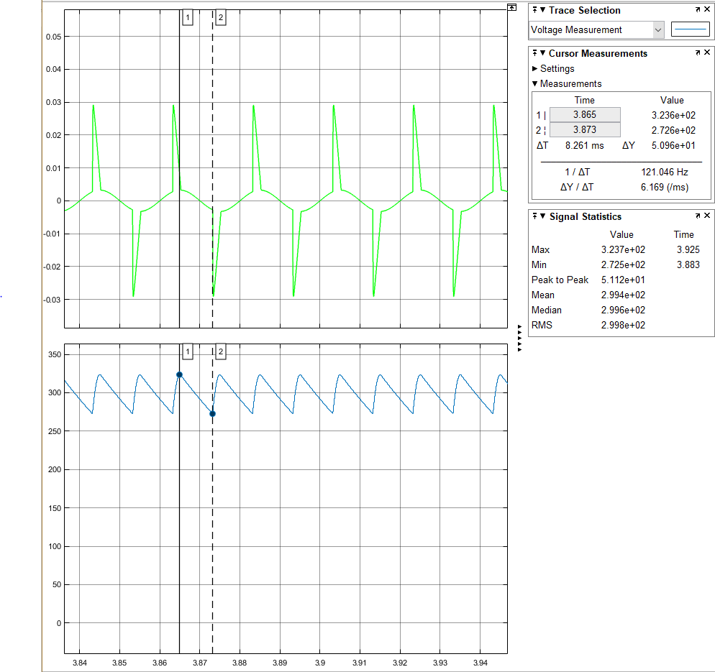

Figure 13: Output voltage waveform with RC load R=100Ω C=0.47uF (Blue Line is the Output Voltage)

<http://www.chemi-con.co.jp/cgi-bin/CAT_DB/SEARCH/cat_db_al.cgi?e=e&j=p&pdfname=smg> is a link to selected capacitor datasheet and manufacturer code is *ESMG351ELLR47MF11D*

### Part 2.4

There is a difference in average value of the output voltage where there is no line inductance case with same load. The presence of the line inductance causes a lower average output voltage. This drop is due to commutation. Moreover, THD of the line currents are different as shown in *Figure 11* and *Figure 14.* The difference in THD caused by line inductance.

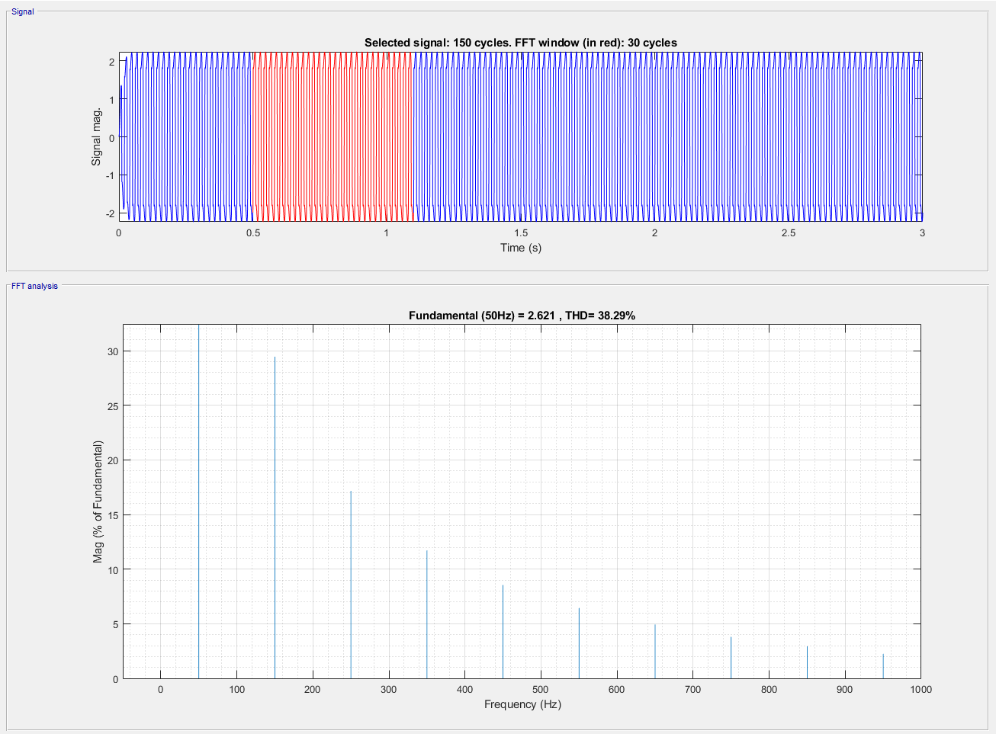

Figure 14: THD= 38.29% with RL Load R=25 Ω L=1H and line inductance of 10mH

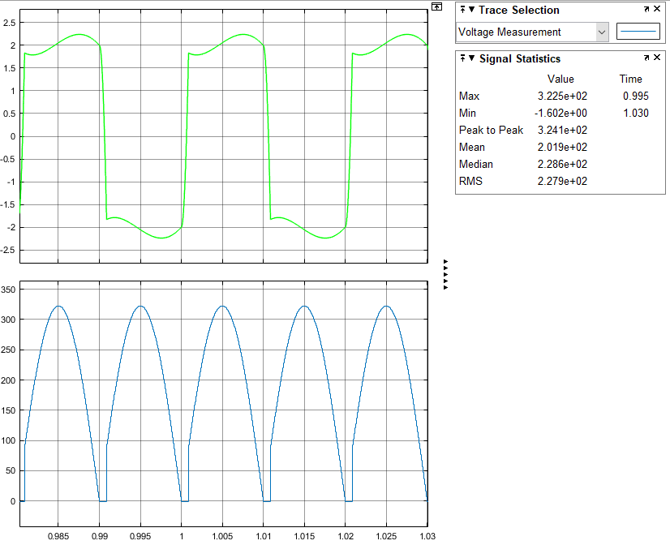

Figure 15: Average output voltage is 201.9V % with RL Load R=25 Ω L=1H and line inductance of 10mH